1-Mobile Network - Base Stations (BTS)

📶 What Is a Base Transceiver Station (BTS)?
# Source: AI Source: Provided by: [Data Path: Persons Table -> ID Column: 1, Name_En Column: Motasem Essam] -> From: [ChatGPT] on [1/23/2026]
A Base Transceiver Station (BTS) is the physical equipment at a cell site (tower) that sends and receives radio signals to and from mobile devices. It is the part of the cellular network that directly communicates with your phone using radio waves.
In simple terms:
A BTS is the “voice” and “ears” of a cell tower — it handles the actual wireless communication between your device and the network.

🧱 What Does a BTS Do?
# Source: AI Source: Provided by: [Data Path: Persons Table -> ID Column: 1, Name_En Column: Motasem Essam] -> From: [ChatGPT] on [1/23/2026]
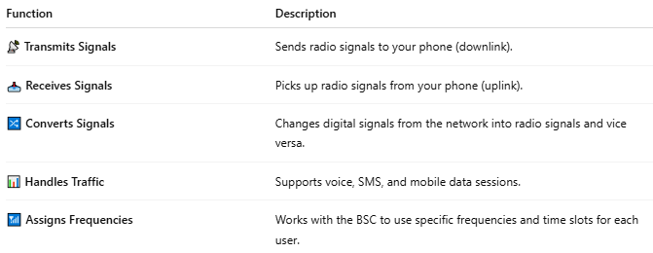

Function | Description
📡 Transmits Signals | Sends radio signals to your phone (downlink).
📥 Receives Signals | Picks up radio signals from your phone (uplink).
🔀 Converts Signals | Changes digital signals from the network into radio signals and vice versa.
📊 Handles Traffic | Supports voice, SMS, and mobile data sessions.
📶 Assigns Frequencies | Works with the BSC to use specific frequencies and time slots for each user.

🧩 BTS in the Network Hierarchy:
# Source: AI Source: Provided by: [Data Path: Persons Table -> ID Column: 1, Name_En Column: Motasem Essam] -> From: [ChatGPT] on [1/23/2026]
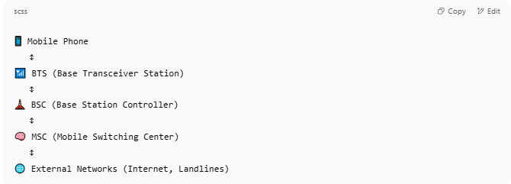

📱 Mobile Phone
↕
📶 BTS (Base Transceiver Station)
↕
🗼 BSC (Base Station Controller)
↕
🧠 MSC (Mobile Switching Center)
↕
🌐 External Networks (Internet, Landlines)

🔧 What Is Inside a BTS?
# Source: AI Source: Provided by: [Data Path: Persons Table -> ID Column: 1, Name_En Column: Motasem Essam] -> From: [ChatGPT] on [1/23/2026]
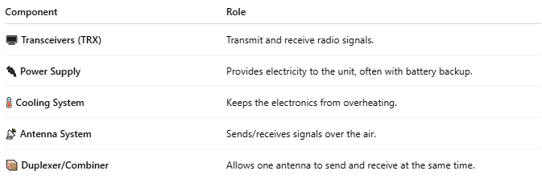

Component | Role
🖥️ Transceivers (TRX) | Transmit and receive radio signals.
🔌 Power Supply | Provides electricity to the unit, often with battery backup.
🌡️ Cooling System | Keeps the electronics from overheating.
📡 Antenna System | Sends/receives signals over the air.
📦 Duplexer/Combiner | Allows one antenna to send and receive at the same time.

📍 Types of BTS:
# Source: AI Source: Provided by: [Data Path: Persons Table -> ID Column: 1, Name_En Column: Motasem Essam] -> From: [ChatGPT] on [1/23/2026]
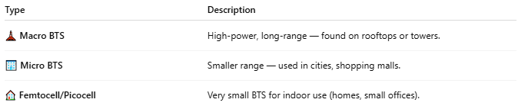

Type | Description
🗼 Macro BTS | High-power, long-range — found on rooftops or towers.
🏢 Micro BTS | Smaller range — used in cities, shopping malls.
🏠 Femtocell/Picocell | Very small BTS for indoor use (homes, small offices).

📖 Summary:
# Source: AI Source: Provided by: [Data Path: Persons Table -> ID Column: 1, Name_En Column: Motasem Essam] -> From: [ChatGPT] on [1/23/2026]
A Base Transceiver Station (BTS) is the frontline equipment at a cell tower that directly connects your phone to the mobile network. It handles all wireless communication between your device and the network infrastructure, enabling calls, texts, and data.
Would you like a diagram showing the BTS-to-phone signal flow, or a breakdown of macro vs micro BTS setups?

2-Base Station Controller (BSC)

🗼 What Is a Base Station Controller (BSC)?
# Source: AI Source: Provided by: [Data Path: Persons Table -> ID Column: 1, Name_En Column: Motasem Essam] -> From: [ChatGPT] on [1/23/2026]
A Base Station Controller (BSC) is a central part of a cellular network that manages multiple cell towers (Base Transceiver Stations or BTS). It acts as the middle layer between the cell towers and the Mobile Switching Center (MSC).
Think of the BSC as the "traffic manager" that controls how phones connect to towers and move between them.

🔧 Main Functions of a BSC:
# Source: AI Source: Provided by: [Data Path: Persons Table -> ID Column: 1, Name_En Column: Motasem Essam] -> From: [ChatGPT] on [1/23/2026]
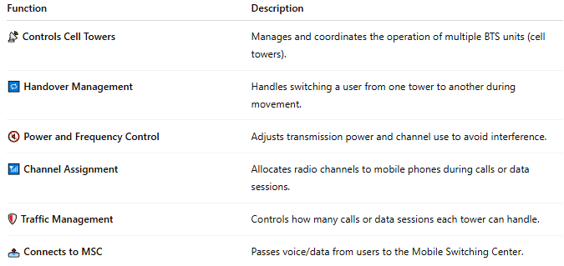

Function | Description
📡 Controls Cell Towers | Manages and coordinates the operation of multiple BTS units (cell towers).
🔁 Handover Management | Handles switching a user from one tower to another during movement.
🔇 Power and Frequency Control | Adjusts transmission power and channel use to avoid interference.
📶 Channel Assignment | Allocates radio channels to mobile phones during calls or data sessions.
🛡️ Traffic Management | Controls how many calls or data sessions each tower can handle.
📤 Connects to MSC | Passes voice/data from users to the Mobile Switching Center.

🧩 Where the BSC Fits in the Network:
# Source: AI Source: Provided by: [Data Path: Persons Table -> ID Column: 1, Name_En Column: Motasem Essam] -> From: [ChatGPT] on [1/23/2026]
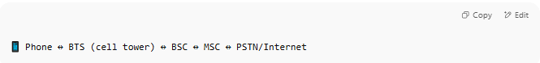
📱 Phone ↔ BTS (cell tower) ↔ BSC ↔ MSC ↔ PSTN/Internet

- BTS (Base Transceiver Station): Physical tower that talks to your phone.
- BSC: Controls BTS units and connects them to the MSC.
- MSC (Mobile Switching Center): Routes calls/data to other users or networks.

📡 Real-Life Analogy:
# Source: AI Source: Provided by: [Data Path: Persons Table -> ID Column: 1, Name_En Column: Motasem Essam] -> From: [ChatGPT] on [1/23/2026]
Imagine a BSC as the manager of a group of employees (BTS units):
- It tells them when to work (channel assignment),
- Transfers tasks between them (handover),
- And reports to upper management (the MSC).

📖 Summary:
# Source: AI Source: Provided by: [Data Path: Persons Table -> ID Column: 1, Name_En Column: Motasem Essam] -> From: [ChatGPT] on [1/23/2026]
A Base Station Controller (BSC) is a vital part of a cellular network. It manages multiple cell towers, controls radio communication, handles user movement, and forwards signals to the Mobile Switching Center. It ensures smooth and efficient mobile connectivity across a region.

3-Mobile Switching Center (MSC)

🧠 What Is a Mobile Switching Center (MSC)?
# Source: AI Source: Provided by: [Data Path: Persons Table -> ID Column: 1, Name_En Column: Motasem Essam] -> From: [ChatGPT] on [1/23/2026]
A Mobile Switching Center (MSC) is a central controller in a cellular network that manages call routing, data transmission, user mobility, and connections between cell towers and external networks.
Think of the MSC as the "brain" of the mobile network — it makes sure your calls and data reach the right place, even when you’re moving.

🔧 Key Functions of an MSC:
# Source: AI Source: Provided by: [Data Path: Persons Table -> ID Column: 1, Name_En Column: Motasem Essam] -> From: [ChatGPT] on [1/23/2026]
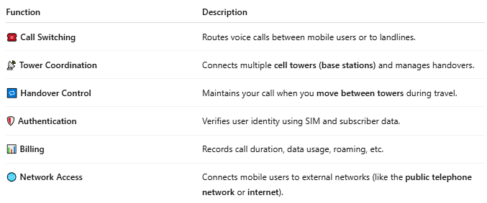

Function | Description
☎️ Call Switching | Routes voice calls between mobile users or to landlines.
📡 Tower Coordination | Connects multiple cell towers (base stations) and manages handovers.
🔁 Handover Control | Maintains your call when you move between towers during travel.
🛡️ Authentication | Verifies user identity using SIM and subscriber data.
📊 Billing | Records call duration, data usage, roaming, etc.
🌐 Network Access | Connects mobile users to external networks (like the public telephone network or internet).

🧩 Components Around an MSC:
# Source: AI Source: Provided by: [Data Path: Persons Table -> ID Column: 1, Name_En Column: Motasem Essam] -> From: [ChatGPT] on [1/23/2026]
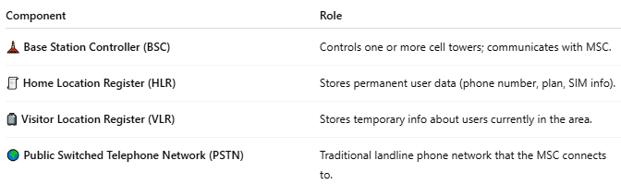

Component | Role
🗼 Base Station Controller (BSC) | Controls one or more cell towers; communicates with MSC.
🧾 Home Location Register (HLR) | Stores permanent user data (phone number, plan, SIM info).
🧳 Visitor Location Register (VLR) | Stores temporary info about users currently in the area.
🌍 Public Switched Telephone Network (PSTN) | Traditional landline phone network that the MSC connects to.

📡 How MSC Works (Example):
# Source: AI Source: Provided by: [Data Path: Persons Table -> ID Column: 1, Name_En Column: Motasem Essam] -> From: [ChatGPT] on [1/23/2026]
- You make a call on your mobile phone.
- The nearest cell tower sends the signal to the BSC.
- The BSC forwards the signal to the MSC.
- The MSC checks your identity (via HLR/VLR).
- It routes the call to the other phone — mobile or landline.
- If you move, it hands over control to another cell tower smoothly.

🧠 Summary:
# Source: AI Source: Provided by: [Data Path: Persons Table -> ID Column: 1, Name_En Column: Motasem Essam] -> From: [ChatGPT] on [1/23/2026]
A Mobile Switching Center (MSC) is a core controller in mobile networks that routes calls and data, authenticates users, and coordinates cell towers. Without the MSC, mobile networks wouldn’t know who you are, where you are, or who you’re trying to reach.

4-IWMSC

🔄 What Is an Interworking Mobile Switching Center (IWMSC)?
# Source: AI Source: Provided by: [Data Path: Persons Table -> ID Column: 1, Name_En Column: Motasem Essam] -> From: [ChatGPT] on [1/23/2026]
The Interworking Mobile Switching Center (IWMSC) is a specialized Mobile Switching Center (MSC) used specifically for handling SMS messages that are coming from or going to other networks, especially international or external systems.
📬 Think of the IWMSC as a gateway for SMS traffic between your mobile network and outside networks (like other carriers or countries).

🧩 What IWMSC Does:
# Source: AI Source: Provided by: [Data Path: Persons Table -> ID Column: 1, Name_En Column: Motasem Essam] -> From: [ChatGPT] on [1/23/2026]
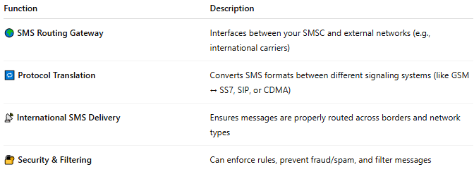

Function | Description
🌍 SMS Routing Gateway | Interfaces between your SMSC and external networks (e.g., international carriers)
🔁 Protocol Translation | Converts SMS formats between different signaling systems (like GSM ↔ SS7, SIP, or CDMA)
📡 International SMS Delivery | Ensures messages are properly routed across borders and network types
🔐 Security & Filtering | Can enforce rules, prevent fraud/spam, and filter messages

📦 Where IWMSC Fits in SMS Flow:

📤 When sending an international SMS:
# Source: AI Source: Provided by: [Data Path: Persons Table -> ID Column: 1, Name_En Column: Motasem Essam] -> From: [ChatGPT] on [1/23/2026]
- 📱 You send a text to a foreign number.
- 📡 Your SMSC forwards the message to the IWMSC.
- 🔄 IWMSC processes the message and routes it to the correct international carrier.

📥 When receiving:
# Source: AI Source: Provided by: [Data Path: Persons Table -> ID Column: 1, Name_En Column: Motasem Essam] -> From: [ChatGPT] on [1/23/2026]
- 🌐 A foreign network sends SMS to you.
- 🔁 The message goes through your IWMSC.
- 📩 IWMSC forwards it to your SMSC, which delivers it to your phone.

🔁 IWMSC vs MSC vs SMSC:
# Source: AI Source: Provided by: [Data Path: Persons Table -> ID Column: 1, Name_En Column: Motasem Essam] -> From: [ChatGPT] on [1/23/2026]
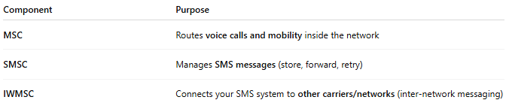

Component | Purpose
MSC | Routes voice calls and mobility inside the network
SMSC | Manages SMS messages (store, forward, retry)
IWMSC | Connects your SMS system to other carriers/networks (inter-network messaging)

🧠 In Summary:
# Source: AI Source: Provided by: [Data Path: Persons Table -> ID Column: 1, Name_En Column: Motasem Essam] -> From: [ChatGPT] on [1/23/2026]
The Interworking MSC (IWMSC) is a:
- 🔌 Bridge between mobile SMS systems and external networks
- 🛂 Gatekeeper for international SMS traffic
- ⚙️ Converter for different message formats and signaling standards
It ensures your texts reach users outside your network, reliably and securely.

5-SMSC

📩 What Is an SMSC (Short Message Service Center)?
# Source: AI Source: Provided by: [Data Path: Persons Table -> ID Column: 1, Name_En Column: Motasem Essam] -> From: [ChatGPT] on [1/23/2026]
An SMSC, or Short Message Service Center, is a core component of a mobile network responsible for receiving, storing, forwarding, and delivering SMS (Short Message Service) messages.
🧠 You can think of an SMSC as the “post office” for text messages — it handles and routes every SMS sent from or to a mobile device.

🔁 How SMSC Works (Simplified Flow):
# Source: AI Source: Provided by: [Data Path: Persons Table -> ID Column: 1, Name_En Column: Motasem Essam] -> From: [ChatGPT] on [1/23/2026]
- 📱 You send an SMS → your phone sends it to the SMSC.
- 📡 The SMSC stores the message if the recipient is unavailable.
- 📬 Once the recipient is reachable, the SMSC forwards the message.
- ✅ If successful, the SMSC sends a delivery report (if requested).

🧩 Functions of an SMSC:
# Source: AI Source: Provided by: [Data Path: Persons Table -> ID Column: 1, Name_En Column: Motasem Essam] -> From: [ChatGPT] on [1/23/2026]
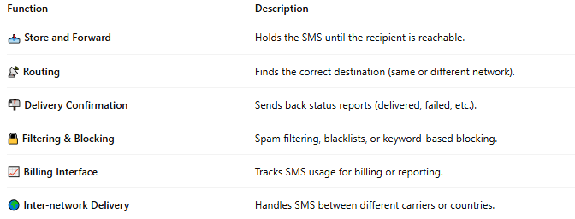

Function | Description
📥 Store and Forward | Holds the SMS until the recipient is reachable.
📡 Routing | Finds the correct destination (same or different network).
📬 Delivery Confirmation | Sends back status reports (delivered, failed, etc.).
🔒 Filtering & Blocking | Spam filtering, blacklists, or keyword-based blocking.
📈 Billing Interface | Tracks SMS usage for billing or reporting.
🌍 Inter-network Delivery | Handles SMS between different carriers or countries.

🧠 Components Involved:
# Source: AI Source: Provided by: [Data Path: Persons Table -> ID Column: 1, Name_En Column: Motasem Essam] -> From: [ChatGPT] on [1/23/2026]
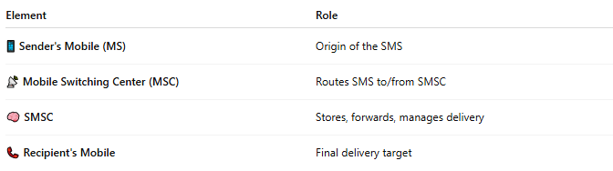

Element | Role
📱 Sender's Mobile (MS) | Origin of the SMS
📡 Mobile Switching Center (MSC) | Routes SMS to/from SMSC
🧠 SMSC | Stores, forwards, manages delivery
📞 Recipient's Mobile | Final delivery target

📜 SMSC Example in Action:
# Source: AI Source: Provided by: [Data Path: Persons Table -> ID Column: 1, Name_En Column: Motasem Essam] -> From: [ChatGPT] on [1/23/2026]
- You send "Hi" to your friend at 2 AM.
- Their phone is off → SMSC stores your message.
- At 8 AM, their phone reconnects → SMSC forwards the SMS.
- You get a delivery report: "Delivered at 08:02 AM".

🛠️ Technical Standards:
# Source: AI Source: Provided by: [Data Path: Persons Table -> ID Column: 1, Name_En Column: Motasem Essam] -> From: [ChatGPT] on [1/23/2026]
- 📡 Works in GSM, UMTS, LTE networks
- Communicates via protocols like SMPP, MAP, SIP, or HTTP API
- Integrated with HLR/VLR, MSC, and Billing Systems

📖 Summary:
# Source: AI Source: Provided by: [Data Path: Persons Table -> ID Column: 1, Name_En Column: Motasem Essam] -> From: [ChatGPT] on [1/23/2026]
The SMSC is the core system behind SMS delivery:
- Stores SMS temporarily if needed
- Delivers messages to the right mobile
- Sends status reports and helps with inter-carrier routing
Without the SMSC, text messaging wouldn't work.

6-CBC

🏢 What Is a Cell Broadcast Center (CBC)?
# Source: AI Source: Provided by: [Data Path: Persons Table -> ID Column: 1, Name_En Column: Motasem Essam] -> From: [ChatGPT] on [1/23/2026]
The Cell Broadcast Center (CBC) is a core network component in mobile networks responsible for creating, managing, and distributing cell broadcast messages (SMS-CB) to mobile users in specific geographic areas.
🧠 Think of it as the central control tower for emergency or public alerts, sending messages to all phones near certain cell towers — without needing their numbers.

📡 Role of the CBC in the Network:
# Source: AI Source: Provided by: [Data Path: Persons Table -> ID Column: 1, Name_En Column: Motasem Essam] -> From: [ChatGPT] on [1/23/2026]
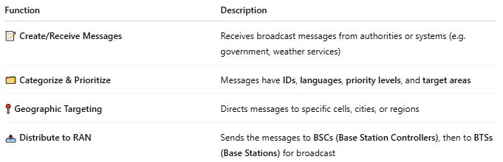

Function | Description
📝 Create/Receive Messages | Receives broadcast messages from authorities or systems (e.g. government, weather services)
🗂️ Categorize & Prioritize | Messages have IDs, languages, priority levels, and target areas
📍 Geographic Targeting | Directs messages to specific cells, cities, or regions
📤 Distribute to RAN | Sends the messages to BSCs (Base Station Controllers), then to BTSs (Base Stations) for broadcast

📡 Message Flow (Simplified):
# Source: AI Source: Provided by: [Data Path: Persons Table -> ID Column: 1, Name_En Column: Motasem Essam] -> From: [ChatGPT] on [1/23/2026]
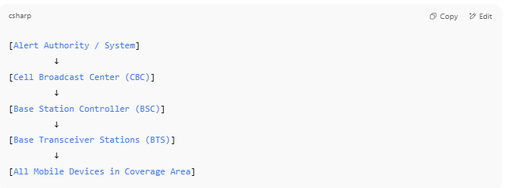

[Alert Authority / System]
↓
[Cell Broadcast Center (CBC)]
↓
[Base Station Controller (BSC)]
↓
[Base Transceiver Stations (BTS)]
↓
[All Mobile Devices in Coverage Area]

📦 Features of CBC:
# Source: AI Source: Provided by: [Data Path: Persons Table -> ID Column: 1, Name_En Column: Motasem Essam] -> From: [ChatGPT] on [1/23/2026]
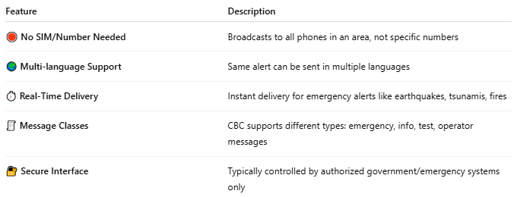

Feature | Description
🛑 No SIM/Number Needed | Broadcasts to all phones in an area, not specific numbers
🌍 Multi-language Support | Same alert can be sent in multiple languages
⏱️ Real-Time Delivery | Instant delivery for emergency alerts like earthquakes, tsunamis, fires
🧾 Message Classes | CBC supports different types: emergency, info, test, operator messages
🔐 Secure Interface | Typically controlled by authorized government/emergency systems only

🆚 CBC vs SMSC:
# Source: AI Source: Provided by: [Data Path: Persons Table -> ID Column: 1, Name_En Column: Motasem Essam] -> From: [ChatGPT] on [1/23/2026]
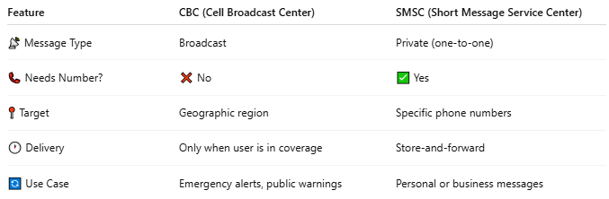

Feature | CBC (Cell Broadcast Center) | SMSC (Short Message Service Center)
📡 Message Type | Broadcast | Private (one-to-one)
📞 Needs Number? | ❌ No | ✅ Yes
📍 Target | Geographic region | Specific phone numbers
🕐 Delivery | Only when user is in coverage | Store-and-forward
🔄 Use Case | Emergency alerts, public warnings | Personal or business messages

🧠 Used For:
# Source: AI Source: Provided by: [Data Path: Persons Table -> ID Column: 1, Name_En Column: Motasem Essam] -> From: [ChatGPT] on [1/23/2026]
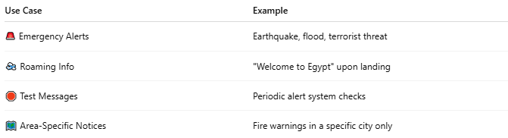

Use Case | Example
🚨 Emergency Alerts | Earthquake, flood, terrorist threat
🛫 Roaming Info | "Welcome to Egypt" upon landing
🛑 Test Messages | Periodic alert system checks
🗺️ Area-Specific Notices | Fire warnings in a specific city only

📖 Summary:
# Source: AI Source: Provided by: [Data Path: Persons Table -> ID Column: 1, Name_En Column: Motasem Essam] -> From: [ChatGPT] on [1/23/2026]
CBC (Cell Broadcast Center) is:
- 🏢 The main controller for cell broadcast (SMS-CB) messages
- 📍 Targets areas, not people
- 🚨 Sends real-time alerts for emergencies, public warnings, or system messages
- 📡 Delivers messages via mobile towers, reaching all nearby phones at once

